Langley Mill Church of England Infant School and Nursery – Curious Cotton Mice (Nursery) Medium Term Plan – Summer 5 2025
Immersion Event  - Planting flowers, fruit and vegetables  - Spring/summer environmental walk  - Butterflies and ladybirds | Additional Event:  ACES Day - 1.5.25  IDAHOBIT - 17.5.25 |  | Reading / Book Event:  National Share a Story month |  | Parent Partnership Events  Woodland Adventure
Key Texts  - Jack and the beanstalk  - Over in the meadow  - The enormous turnip  - Tree full of wonder- Anna Smithers  - There’s a Tiger in my Garden-Lizzy Stewert  - My shadow – Robert Louis Stevenson  Other books that are going to read during our topic:  Mad about minibeasts  Planting a rainbow  Jaspers beanstalk |  | What is down the garden?  For this term we will be starting our Topic ‘What is down the garden?’ where we will be continuing to learn all about Spring and new beginnings. We will be outdoors investigating, exploring and discussing the new changes in seasons, different life cycles, mothers and their babies. |  | Key Nursery Rhymes  - Incy Wincy Spider  - Baa Baa Black Sheep  - Mary Mary  - 5 Little ducks  - 5 Little speckled frogs  - Wiggly Woo
Home Learning  Reading:  - To ensure success, all children are expected to regularly share stories at home. Bedtime is an ideal time to share books to end the day calmly and induce sleep.  - It is helpful not just to read books but point out and talk about text when out and about so children learn that print carries meaning. You can do this with so many things such as road signs, supermarket labels, shopping lists, etc.  Weekly tasks:  - Read for enjoyment, this may be books off your own bookshelf, bedtime stories, magazines and local library visits.  - Allow your child to be creative – draw, paint and create using junk, practising using scissors, glue, staplers etc – send us any creations via Dojo.  - Now the weather is getting better see if your child can learn a new active skill – hopping, jumping, balancing. |  | Reminders  Please could we ask for you to try and discourage your child from bringing their own toys from home. We will also encourage this at the beginning on the nursery session. Thank you.  Sessions:  - Morning session time 8:45AM – 11:45AM  - Afternoon session time 12:30PM – 15:30PM  - You can access 15 or 30 hours (if eligibility is met).  - Those that access 30 hours must pay an additional £3 to cover the lunch period. Lunch is £2.60 extra.  Food and Drink:  - Please send your child to school with an empty, capped, named water bottle each Monday morning. This will be returned every Friday for washing over the weekend.  - Any children staying a full day can bring their own packed lunch or access the daily lunch service. This costs £2.30 and you can have a hot lunch or cold sandwich. Any home packed lunches must meet our nutritional, healthy standards.  Clothing:  - Uniform is not statutory in nursery. All children must wear comfortable clothes that are suitable for the weather and can get dirty. We spend lots of time outside in all weathers so sturdy shoes are a must.  - We do not allow the children to wear jewellery, including the wearing of earrings unless discussed with the headteacher.  - Please send your child to nursery with a spare set of weather appropriate clothing in named bag that. If your child is not yet fully toilet trained they need to have spare nappies, wipes and clothes. The bag will remain in nursery until the end of each term.  - Every child needs a pair of named wellies on their peg in a plastic bag to make the most of our wonderful school grounds in all weather.  - Please ensure your child brings a named water bottle that can remain in nursery.  Staffing:  - The teacher will Mrs Harris.  - The full-time teaching assistant will be Mrs Hughes.  - The AM teaching assistant will be Mrs Clarke and the PM teaching assistant will be Mrs Summers.  - The 1-2-1 support teaching assistant will be Miss Frost. |  | Prior Learning  - Before starting nursery the children should have an idea about where they live and who they live with.  - They should have been encouraged to talk in short, clear sentences and be able to understand and follow simple instructions.  Autumn Prior learning  - They should attempt to put on / take off coats and shoes with some level of independence.  - They will have experienced drinking from cups and tooth brushing.  - They will have taken part in some family celebrations such as birthdays, anniversaries, weddings and parties.  - They will know the name of different weather types and have experienced what they feel like such as rain, wind, sun, fog and maybe snow.  Spring Prior Learning  - The children will be able to name and talk in detail about the different seasons.  - They will have experienced many different experiments that include ice, water and temperature change.  - The children will be able to name and talk about some of the different animal groups and what makes them that kind of animal.  - The children will be able to discuss different animals from around the world and if they make a good pet.
Langley Mill Church of England Infant School and Nursery – Curious Cotton Mice (Nursery) Medium Term Plan – Summer 5 2022-23
Communication and Language  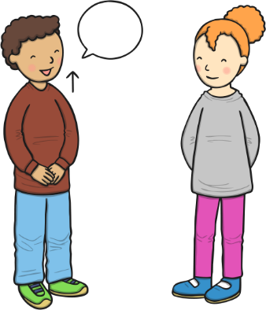  As communicators, the children will have developed their listening skills and will be encouraged to do so for a longer period of time.  The children will continue to develop their listening and communication skills by joining in with conversations appropriately and accurately. It is important that this term the children are support to develop and learn new vocabulary and use this to create longer sentences.  The children will begin to use the new question all to develop and extend their language. They children will be expected to be able to understand and ask why questions in terms of investigations. To support this, there will be a planned ‘question time’ each Monday.  The children will be able to follow simple instructions accurately that involve two actions such as “please find your shoes and put them on”. | Personal, Social and Emotional Development  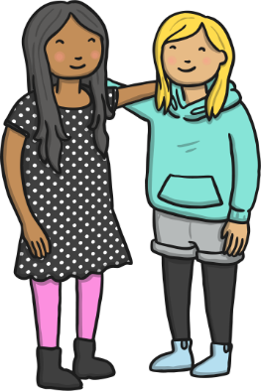  As young citizens, the children will be expected to select and use resources that are available for them to use in the classroom independently. The children will be supported by the adults to use the outdoor equipment from the shed. There is always a range of different activities for the children to select from whilst in Nursery, they will be given opportunity throughout the day to choose from both inside and outside activities.  The children will continue to carry out given tasks both independently and in a group. This term there will be opportunities to share, take turns and resolve conflicts using a variety of traditional games. The adults within nursery will continue to support the children throughout.  The children will also be supported to name, recognise and describe their feelings. This will be taught in planned lessons and in the moment. The children will feel confident to independently use our calm corner if and when it is needed to support their emotions and feelings.  We will continue use our Bucket Filling books to talk about expected behaviour in nursery, so that all children treat each other and the environment with care. We want to be bucket fillers not bucket dippers! |  |   Physical Development  As movers, the children have a weekly dedicated PE slot. This term our P.E focus is ‘The Little Book of Dance’. The children will use their creative development through dance experiences through a series of flexible sessions. The children will learn to use both their fine and gross motor skills to move it different ways.  There will be a focus on throwing, catching, and bat and games. The children will be given an array of resources such as balls, bats, streamers, frisbees and stilts in the nursery garden to choose from to develop these skills. The children will be given the opportunity to develop their balancing skills through the choice of bikes, scooters and cars.  We will learn to make healthy choices by looking and trying new and healthy foods.  Within the provision we will continue to provide a Funky Fingers area with an activity designed to develop the children’s hand control/movements. During this term the children gain confidence in using one-handed tools and be confident grip when some control when using them. This term we will focus on writing some letters of our name in the correct order.
Literacy    As readers, the children will continue to work on their pre-reading skills.  The children will be recapping aspects 4 and 5 to ensure we have a good understanding of rhyme alliteration. The children will. We will then be focusing on aspect 6 and 7 and will begin to recognise different sounds and continue develop their oral blending and segmenting skills following ideas given on the Letters and Sounds Scheme (Phase 1). The children will continue to be provided phonics related games in independent learning as well as group taught ready for starting Sounds-Write.  The children will be able to talk about stories that we have heard such as the very hungry caterpillar, the busy spider, over in the meadow and use this to aid their play. The children will be provided a language rich environment with topic-based from books, word of mouth and class research words to support their vocabulary during this term.  As writers, the children will begin to write some letters of their name with good formation with support from an adult. This will be supported through a variety of different writing aids such as pencils, chalk, paper, lined note books, chalk boards, whiteboards, etcher sketchers and more. The children will be supported to use good pencil grip when writing sounds they hear and see in their name.  As above the children will provided with a language rich environment, this provides the children with lots of opportunities to using the phonetical knowledge and practice their writing skills. |  | Mathematics  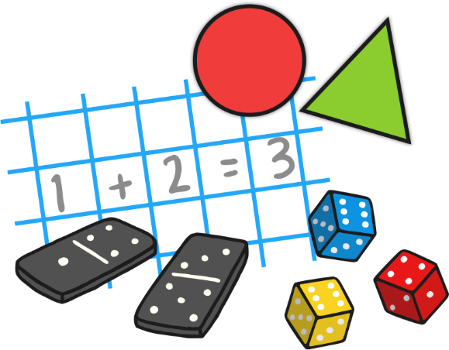  As mathematicians, the children will be following the White Rose Maths Scheme and this term they will learn how to confidently recite numbers to 10 and beyond.  This term we will focusing on subitising up to 3 objects and identifying numbers up to 10. We will begin to investigate words such as greater, less, more, few, equal and use them in the correct context.  We will then explore positional language through the use of maps and BeeBots. The children will be using and learning words such as forwards, backwards, under, over, next to, left and right to ensure their BeeBots go the correct place.  All our learning through-out the term will be replicated in the continuous provision.  The children will be given lots of opportunities to compare different weights, lengths and capacities through more outdoor based activities this term. There will be water, weights, jugs, pots, pans, measuring sticks within the continuous provision to support their maths skills.
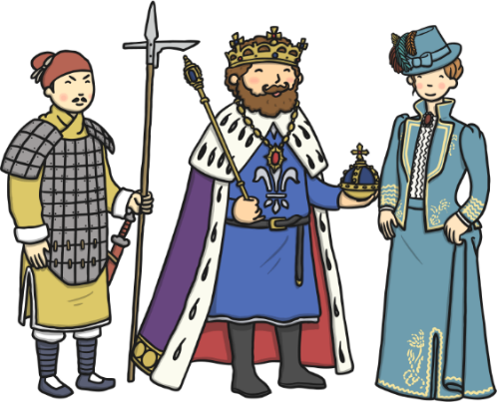  Understanding the World  As historians, the children about investigate our own family history of growing and what our own gardens are like. We will discuss our prior knowledge of plants, growing and the animals/insects that are reborn during Spring time.    As geographers, we will explore the pong and the life underneath the water. We will then delve into the life of frogs and where they come from. We will discuss all sorts of amphibians and where they live.    As scientists, the children will learn all about how to plant, grow and care for different seeds and bulbs. We will investigate the growth, change and decay of them as we make our way through the term. We will also be planting our own fruit and vegetable patch in nursery so we can taste our own produce.  We will also investigate the key features of some insect’s life cycles alongside actually viewing this first hand.  As theologians, the children develop positive attitudes about the differences between people.  As a Christian school the children will be give the opportunity to learn all about different religious stories from the bible and compare them to our own values as small humans.  The children will be given many opportunities to listen to new music. This term within the calm area we will be providing the children with a variety of different classical music, we will then discuss how the different songs made us feel, think and if we liked or disliked it.  Listen to religious music – the natural world |  | 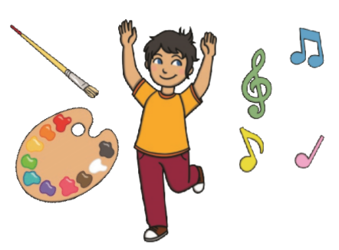  Expressive Arts and Design  As artists, the children will be creating lots of natural pictures using items and treasures we find in the garden. We will use these to create group and individual collages.  We will also be exploring and comparing illustrations from both Eric Carle and Louis Elhert story books and recreating these using similar designs.  As musicians, the children will be provided with musical instruments in the classroom, they will be expected to tap out rhythms, tap to the beat and dance along to the rhythms they make.  We will continue access Charanga’s Song Collection to choose a range of well known, favourite and number songs to support our curriculum and their Listening Activities, which is a collection of stories and listening examples designed especially for younger children. We will also select some of Charanga’s Musical Activities to develop the children’s musical and general skills. These include listening activities, musical games, singing and playing instruments.  As creators, the children will continue to develop their imaginations, role playing in our Vets and through other opportunities such as dressing up, using small world characters and accessing a range of props and open-ended resources.

