Langley Mill Church of England Infant School and Nursery – Curious Cotton Mice (Nursery) Medium Term Plan – Autumn 2 2023-24
Immersion Event  Celebrating a festival  Birthday Party celebration | Additional Event:  Bonfire Night - 5.11.23  Remembrance Day - 11.11.23  Anti-Bullying Week – WC 14.11.23  Winter Solstice - 21.12.23 |  | Reading / Book Event:  National Non-Fiction November  (Bonfire Night, Remembrance, Winter, Christmas) |  | Parent Partnership Events  Christmas Concert – 13.12.23 and 14.12.2023
1. Super tato  2. Ten Rules of Being a Superhero - Deb Pilutti.  3. Real superheroes  4. You can’t call an Elephant in an emergency  5.A superhero like you  6. the busy nativity  7. Dream snow eric carle |  | Are you a superhero?    This topic was chosen to further develop the children’s understanding of members in their local community, who is familiar to them and how they help us. Children will also learn that some places are special to members of their community, where these people work and what is special about these buildings. |  | Key Nursery Rhymes  2. Miss Polly  3. Superhero song  4. 5 little fireman  5. when santa got stuck up the chimney  6. Twinkle, Twinkle Christmas star  7. Jingle Bells  8. Christmas songs
Home Learning  Reading:  - To ensure success, all children are expected to regularly share stories at home. Bedtime is an ideal time to share books to end the day calmly and induce sleep.  - It is helpful not just to read books but point out and talk about text when out and about so children learn that print carries meaning. You can do this with so many things such as road signs, supermarket labels, shopping lists, etc.  We will continue to use the Class DoJo Families App to communicate with you about learning. All other queries and absence matters must be relayed to the school office. |  | Reminders  Please could we ask for you to try and discourage your child from bringing their own toys from home. We will also encourage this at the beginning on the nursery session. Thank you.  Sessions:  - Morning session time 8:45AM – 11:45AM  - Afternoon session time 12:30PM – 15:30PM  - You can access 15 or 30 hours (if eligibility is met).  - Those that access 30 hours must pay an additional £3 to cover the lunch period. Lunch is £3.25 extra.  Food and Drink:  - Please send your child to school with an empty, capped, named water bottle each Monday morning. This will be returned every Friday for washing over the weekend.  - Any children staying a full day can bring their own packed lunch or access the daily lunch service. This costs £3.25 and you can have a hot lunch or cold sandwich. Any home packed lunches must meet our nutritional, healthy standards.  Clothing:  - Uniform is not statutory in nursery. All children must wear comfortable clothes that are suitable for the weather and can get dirty. We spend lots of time outside in all weathers so sturdy shoes are a must.  - We do not allow the children to wear jewellery, including the wearing of earrings.  - Please send your child to nursery with a spare set of weather appropriate clothing in named bag that. If your child is not yet fully toilet trained, they need to have spare nappies, wipes and clothes. The bag will remain in nursery until the end of each term.  - Every child needs a pair of named wellies on their peg in a plastic bag to make the most of our wonderful school grounds in all weather.  Staffing:  - The teacher is Mrs Harris  - The teaching assistants are Mrs Hughes, Mrs Clarke and Mrs Summers. |  | Prior Learning  - Before starting nursery, the children should have a basic understanding about where they live and who they live with.  - They should have been encouraged to talk in short, clear sentences and be able to understand and follow simple instructions.  - They should attempt to put on / take off coats and shoes with some level of independence.  - They will have experienced drinking from cups and tooth brushing.  - They will have taken part in some family celebrations such as birthdays, anniversaries, weddings and parties.  - They will know the name of different weather types and have experienced what they feel like such as rain, wind, sun, fog and maybe snow.
Langley Mill Church of England Infant School and Nursery – Curious Cotton Mice (Nursery) Medium Term Plan – Autumn 2 2023-24
Communication and Language  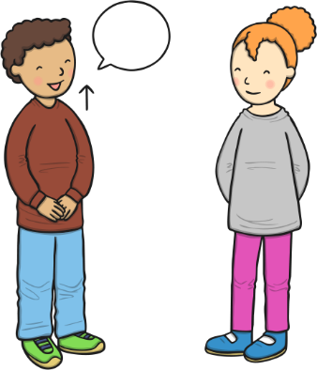  As communicators, the children will be encouraged to pay attention when others are talking and respond when they are spoken to by name. They will be taught basic listening skills, with adults modelling how to listen when someone else is speaking. They will listen to a range of short stories, songs and rhymes all about the different celebrations that we are learning about. They will be supported to join in with any songs, stories and rhymes that are familiar to them and begin to learn and make up their own too.  Following instructions is very important so lots of simple instructions with two key words will give for the children to listen to and follow. All children will be encouraged to speak clearly, saying each other’s names correctly and using simple two or more words sentences. All adults will ask lots of ‘who’, ‘what’, ‘when’ and ‘where’ questions for the children to try and answer in their clear voices. The nursery will be filled with enquiry and discussion, so the children’s speech and vocabularies develop well. | Personal, Social and Emotional Development  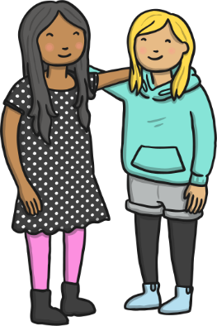  As young citizens, the children will be taught how to use the nursery and it all of its resources appropriately. They will be given lots of freedom and choice to select and use resources which they would like to explore.  The children will be encouraged to talk about their feelings and understand them on a more meaningful level. Activities in our calm corner will be provided to ensure the children feel confident to share their feelings with the adults and children around them.  This term we will continue to develop skills such as sharing, taking turns and listening to each other whilst playing and learning in the nursery.  We will continue use our Bucket Filling books to talk about expected behaviour in nursery, so that all children treat each other and the environment with care. We want to be bucket fillers not bucket dippers!  We will be partaking in Anti-bullying week where we learn all about how to be a good friend in the nursery. |  | 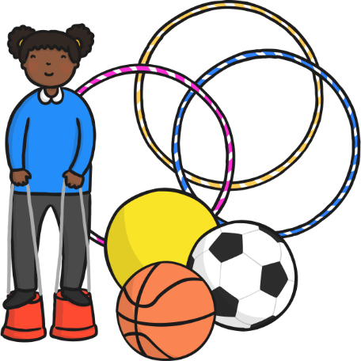  Physical Development  As movers, the children have a weekly dedicated PE slot, this will take place every Friday. This term our P.E focus is physical literacy. Physical literacy is the development of fundamental movement and sport skills, helping the children to advance their gross motor skills.  We will continue to work hard with parents and the children to ensure that all children can use the toilet independently.  The children will continue learning about good hygiene, ensuring we know why it is so important to wash and dry their hands.  Within the provision, we will continue to provide a Funky Fingers area with an activity designed to develop the children’s hand control/movements. We will also begin providing whole group funky finger sessions during the day to develop their fine motor skills.
Literacy  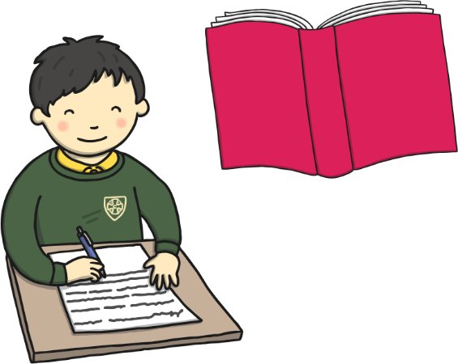  As readers, we will work on pre-reading skills. This includes listening to rhymes and sounds in the environment and using instruments, following the Little Wandle Scheme.  We will read lots of key texts related to the ‘Are you a superhero?’ topic and use these to guide the children’s play. This term there will be an array of both non-fiction and fiction books available for the children to choose from. The children will begin to understand the difference between books that are non-fiction and fiction and choose them appropriately. The children will begin to independently choose stories that interest them and understand how to we read left to right and from top to bottom, how pages are turned, book parts such as front and back cover, etc.  This term we will be focusing on rhyme in songs and listening, learning and swapping rhyming words in our songs. We will also begin to hear and listen for initial sounds in our name and familiar words.  As writers, we will develop the children’s gross motor skills by making large marks e.g., using playground chalk, painting with water. We will use Phase 1 ‘Toy Talk’ to develop the children’s understanding of the sounds in words. A big focus will be on supporting the children to use any print knowledge they have to start writing e.g., m for mummy. This term, we will continue to support the children to write at least the first letter of their name. |  | Mathematics  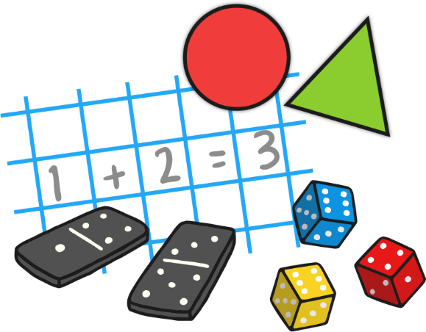  As mathematicians, the children will learn how to confidently recite numbers to 5 and beyond. They will know how to make 2 in different ways, gaining a real grasp of basic number skills.  The children will learn a variety of songs, rhymes and dances to develop their number, shape, space and measure knowledge alongside side planned group sessions taught by the nursery staff.  Within the provision, the children will have lots of opportunities to compare objects – either by size, length, weight or capacity. To develop awareness of time, we will start to use vocabulary to describe the time of the day that things happen e.g., morning, dinner time, afternoon, evening, helping the children differentiate between different parts of the day. The children will also have lots of opportunities to explore and use shapes for building, thinking about which shapes are best for which purpose and why e.g., shapes with flat sides are best for stacking.
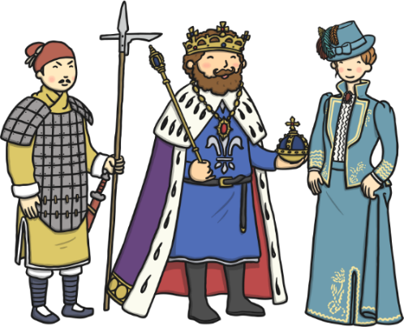  Understanding the World  As historians, the children will be learning all about their world and the world around them through culture, religion and celebrations. We will investigate festivals and celebrations from such as Diwali, Bonfire Night, Hannukah, and Christmas. The children will then be given the opportunity to discuss celebrations that take place in our own homes and compare them to other celebrations and our friends in a positive manner.    As geographers, the children will learn about different religions and cultures from all about the world. Throughout the term we will be talking about many different countries and placing them on a large map that is in our classroom.    As scientists, the children will learn discover new textures and tastes through making and eating lots of different festival foods.    As theologians, the children develop positive attitudes about the differences between people. As a Church School, they will learn our nursery prayers which are recited on entry and at home time. Throughout the term we will seize opportunities to talk about life events.  The children will be given many opportunities to listen and learn new music including a variety of songs relating to the different festivals and celebrations. |  | 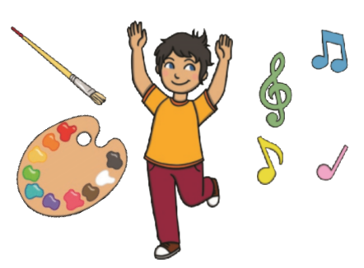  Expressive Arts and Design  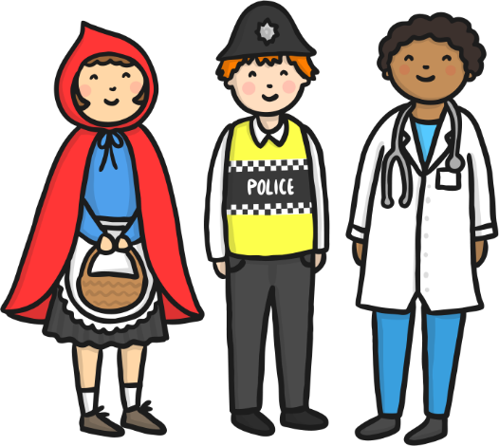    As artists, the children will be focusing on painting this term. We will begin to investigate and discover all about different superhero’s and Christmas, we will then make different pieces of art using our knowledge of our topic. As musicians, the children will continue to learn new nursery rhymes but this term we will be adding our own little twist of changing the word and rhythm.  The children will also be provided with a variety of music and songs to listen, learn and dance to from an array of different cultures and religions.  The children will be given the opportunity to partake in a Christmas concert that will involve learning lots of new Christmas songs, actions and dance moves!  We will continue access Charanga’s Song Collection to choose a range of well known, favourite and number songs to support our curriculum and their Listening Activities, which is a collection of stories and listening examples designed especially for younger children. We will also select some of Charanga’s Musical Activities to develop the children’s musical and general skills. These include listening activities, musical games, singing and playing instruments.  As creators, the children will continue to develop their imaginations, role playing our home corner and through other opportunities such as dressing up, using small world characters and accessing a range of props and open-ended resources.

